Executive Summary
Provide a brief overview of the product concept, including its purpose, target audience, key features, and why you think it should be integrated.

Target Release
Epic | Past
Document Status | {DRAFT} {READY}
Owner | OS

Objective
In collaborative projects, annotations and key information are often overlooked or lost. Team members struggle to keep track of important notes, leading to inefficiencies and miscommunications. A streamlined solution is needed to make essential information easily highlighted and accessible to all team members.

Assumptions
- Users want sticky notes visible for future visits.
- Users can make notes sticky directly from the extension.
- Sticky notes can be enabled/disabled.
- Existing notes can be made sticky/not sticky from the web app.
- All sticky notes are visible on revisits.

Success metrics
List project goals and the metrics you'll use to judge its success

Goal | Metric
e.g., Simplify the user experience | Feature Utilisation Metrics  - Number of Sticky Notes Created: Count the total number of sticky notes created by users.  - Frequency of Sticky Note Usage: Track how often users create, view, and interact with sticky notes.  - Sticky Note Retention: Measure how many sticky notes are still in use after a certain period (e.g., one week, one month).

Requirements

- Toggle to enable/disable sticky notes in the Extension menu.
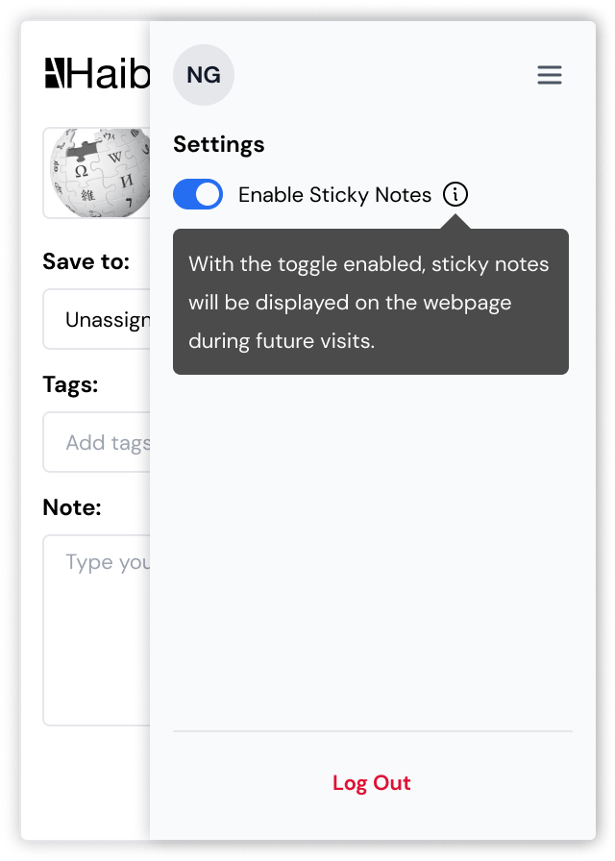

- Toggle sticky notes on, when saving a note.

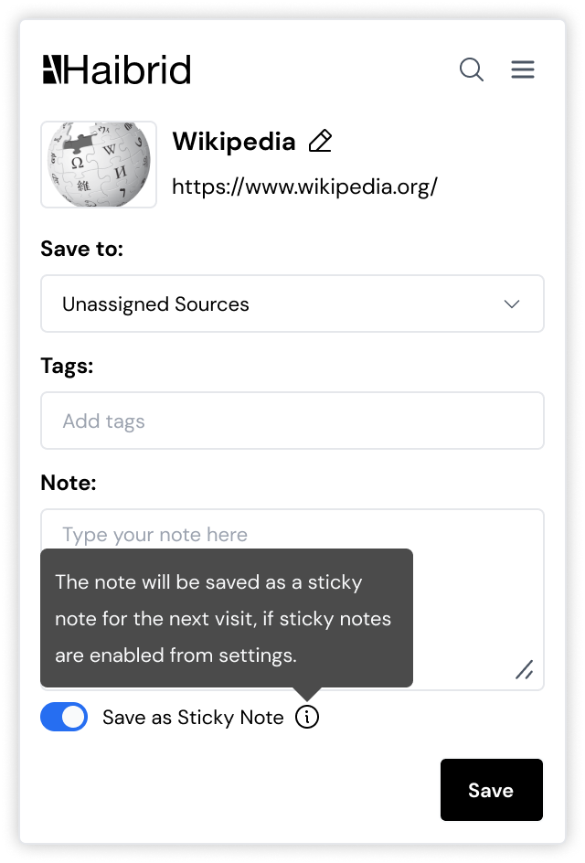

- Make existing notes sticky/not sticky via a "sticky note" icon.
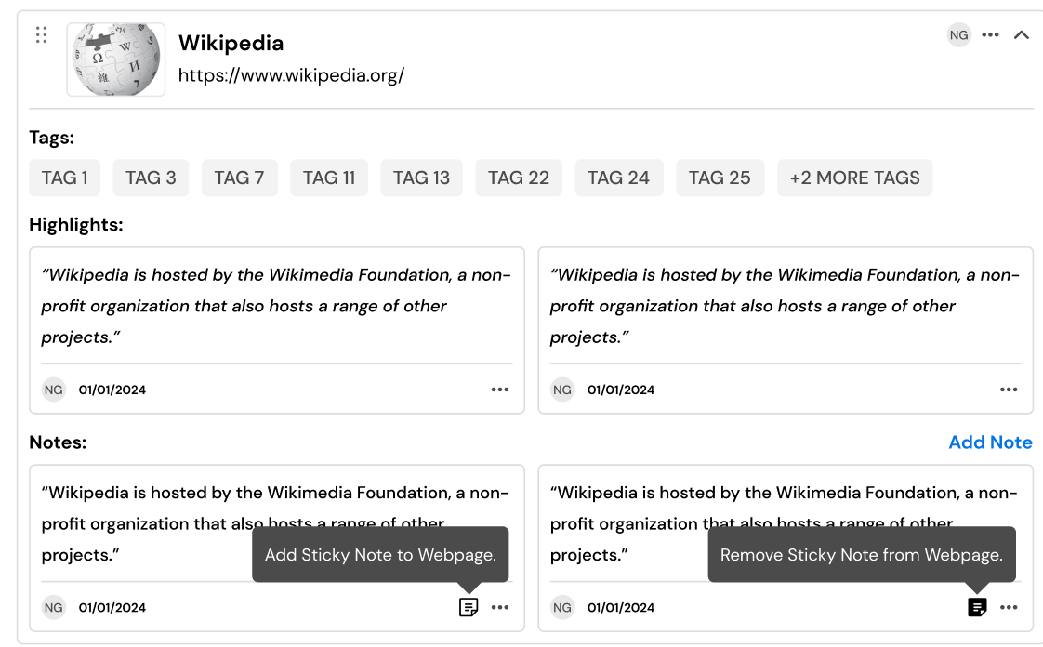

- Display a floating “Haibrid” icon if sticky notes are present.
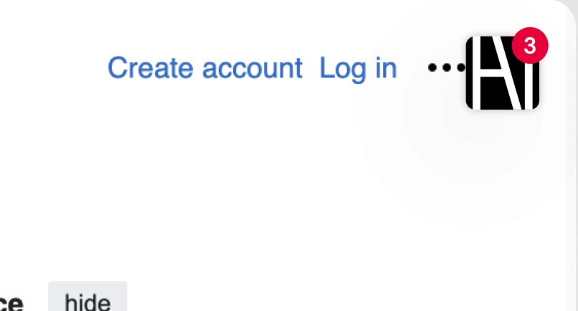

- Expand sticky notes on the first visit.
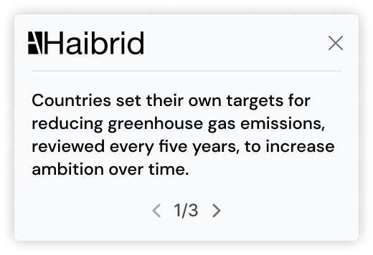

- Number badge on the “Haibrid” icon for new sticky notes (optional).


- Expand sticky notes on clicking the “Haibrid” icon.


- Edit your own notes with a floating edit button.
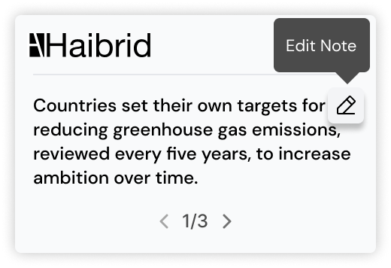
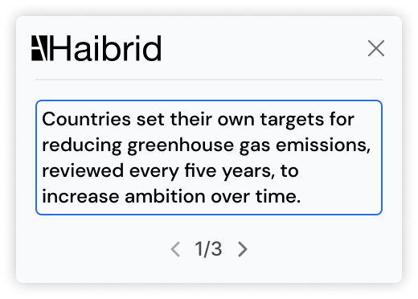

- Slide through multiple sticky notes on a source.

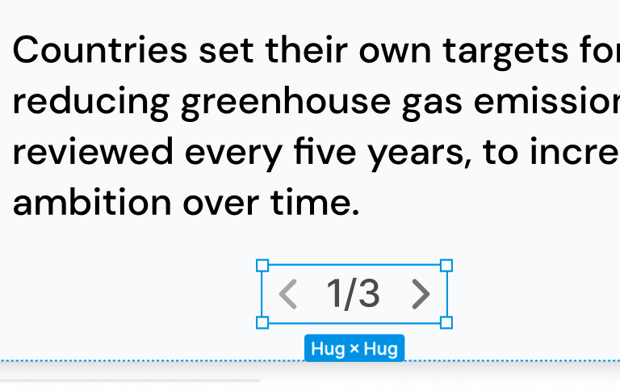

- Extension icon shows a number badge for pages with annotations.



User interaction and design
Add mockups, diagrams, or visual designs related to these requirements.

Open Questions
List all open questions for future discussion, reference or tracking

Out of Scope
List the features discussed which are out of scope or might be revisited in a later release.

